Guidelines for Abstract Preparation for ICTAC XX

First author's first name and family name¹, Second author's first name and family name²*, ...
¹First author's affiliation, City, Country
²Second author's affiliation, City, Country...
*E-mail: Corresponding author's e-mail

Abstract: Abstract is limited to 100 words.11-points.
This is a template of abstract for ICTAC XX, Delft, The Netherlands, 2026. You can directly use this template without changing the format. Please fit the abstract to 1 page of A4-sized paper. Use of Times New Roman font (or equivalent) is strongly recommended.
Keywords: Keyword 1, Keyword 2, Keyword 3.

The title of the abstract is centered with Times New Roman font in 14-point boldface.
Authors’ names are below the title in 11-point. Mark affiliations using superscripted letters (starting from 1). Underline the presenting author’s name and asterisk (*) the corresponding author’s name. The affiliations and the contact information (E-mail address) are italicized in 11-point. The affiliations are given as department and institution names with city, zip code and country.
Texts from Abstract must be in a one-column format. Abstract is limited to 100 words, and three keywords are listed directly below the abstract. The texts of Abstract and keyword should be given in 11-points.
Main text should be given in 11-points. The font type should be “Times New Roman” for all parts including the title and references, with single spaced lines.
Tables and figures are included within 1 page. Images are .jpg or .png, max 2MB. Captions of Tables and Figures are given in 10-point with one line spacing from the text body (see below). References should be indicated in the text in square brackets, such as [1-3] and listed at the end of the paper (10 points). Acknowledgement should be addressed as a last paragraph of the text body.
Your Word file can be submitted on the website of ICTAC XX (https://ictac20.nl). To avoid garbled printout, all the fonts should be embedded in the file. Go to File > Options > Save, and then check the box for "Embed fonts in the file" in the "Preserve fidelity when sharing this document" section
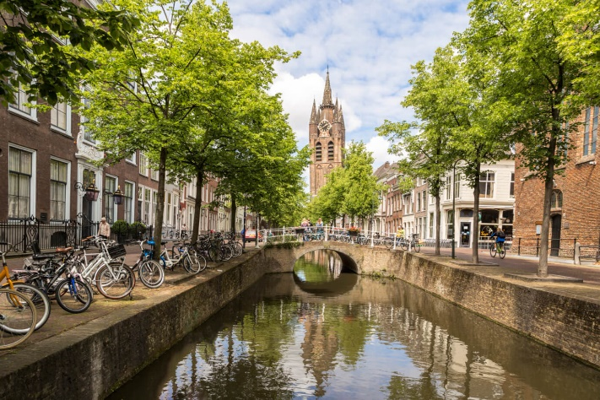
Abstracts must be submitted by February 15, 2026. The acceptance of papers will be announced around March 30, 2026.
Figure.1 Delft Old Church (10-point).

Acknowledgements
This conference is organized by Delft University of Technology and will be supported by many sponsors.

References
[1] E. Pidko, K. Rossi, Journal name., Vol, nr. (year) page number.
[2] G. Li, I. Filot, Journal name., Vol, nr. (year) page number.

